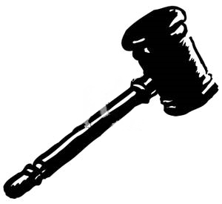 Westbury Forensic Point Leaders 

NAME POINTS DEGREE NEEDED FOR NEXT DEGREE


PRINCESS JEFFERSON 758 SUPERIOR DISTINCTION 242

LAURA MARTINEZ 701 SPECIAL DISTINCTION 49

JALIYYAH HODGE 689 SPECIAL DISTINCTION 61

JALA’ JONES 552 SPECIAL DISTINCTION 198

ADRIANA MOCZYGEMBA 435 DISTINCTION 65

MIRACLE GARDNER 428 DISTINCTION 72

DAVID RAMOS 408 DISTINCTION 92

MONICA GARAY 343 DISTINCTION 157

MIGUEL BRAVO 317 DISTINCTION 183

LORENZO MOORE 194 EXCELLENCE 49

SHAWN CALLIS 188 EXCELLENCE 62

SIERRA VALADEZ 166 EXCELLENCE 84

CINDY VAZQUEZ 157 EXCELLENCE 93

CHINMERI IKO 152 EXCELLENCE 98

CHRISTIAN LEMUS 150 EXCELLENCE 100

A’DARIUS THOMAS 119 HONOR 31

MUTMAINAH ADEYEMI 109 HONOR 41

KEISON PERRY 108 HONOR 42

MILEAH POOLE 98 HONOR 52

KEION GILMORE 87 HONOR 63

MARTHA AGGUIRE-RUBIO 78 HONOR 72

AMPOFO OSEI-TWENEBOAH 77 HONOR 73
ADAM MASON 76 HONOR 74

JEREMY SANDERS 65 MERIT 10

STEPHEN ELDER 63 MERIT 12

AARON ARCENEAUX 52 MERIT 23

BIANKA AMBROCIO 50 MERIT 25

JAMIN PEDROSO 44 MERIT 31

SALLY NGUYEN 30 MERIT 45

ALMOST THERE

JASMINE GABRIEL 20 5

CHARLY GAY 19 6

MONEE THOMAS-LAMBERT 14 11

ZACH THOMAS 14 11

ANNETTE PENA 14 11

MICHAEL MORALES 14 11

WESTBURY HIGH SCHOOL NATIONAL FORENSIC LEAGUE RANKINGS:

NATIONALLY 1663 OUT OF 7804 – 21%

STATE 228 OUT OF 853 – 27%

